Project Design Phase-II
Technology Stack (Architecture & Stack)

Date | 04 October 2026
Team ID | Team 10
Project Name | Import Data using Transform Maps (Spreadsheet)
Maximum Marks | 4 Marks

Technical Architecture:
The Deliverable shall include the architectural diagram as below and the information as per the table1 & table 2
Architecture: Import Data using Transform Maps (Spreadsheet) in ServiceNow
Reference: https://docs.servicenow.com/
Guidelines:
Include all the processes (As an application logic / Technology Block)
Provide infrastructural demarcation (Local / Cloud)
Indicate external interfaces (third party API’s etc.)
Indicate Data Storage components / services
Indicate interface to machine learning models (if applicable)
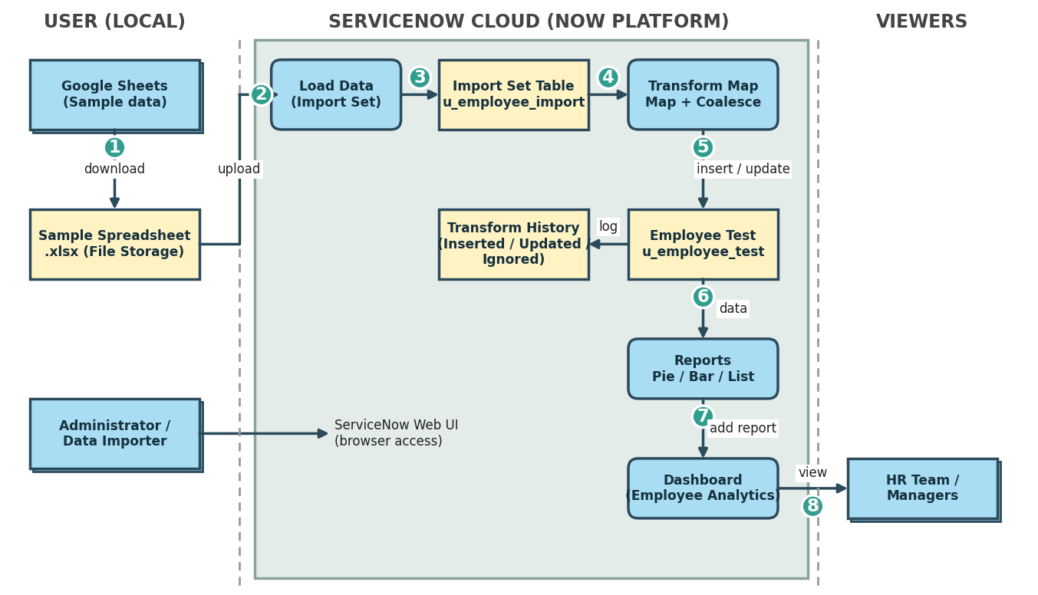

Table-1 : Components & Technologies:
S.No | Component | Description | Technology
 | User Interface | ServiceNow web interface (Application Navigator) used by the administrator for Load Data, Transform Maps, Reports and Dashboards; HR team views the dashboard | ServiceNow Next Experience UI (HTML, CSS, JavaScript provided by the platform)
 | Application Logic-1 | Load Data: uploads the .xlsx file and loads rows into the Import Set table (Employee Import) | ServiceNow Import Sets (Load Data)
 | Application Logic-2 | Transform Map: maps source fields to Employee Test fields (Auto Map / Mapping Assist), runs the transform and applies Coalesce on Employee ID to avoid duplicates | ServiceNow Transform Maps (Field Maps, Coalesce)
 | Application Logic-3 | Reports & Dashboard: Employees by Department (Pie), Employees by Location (Bar) and Employee List Report added to Employee Analytics Dashboards | ServiceNow Reports and Dashboards
 | Database | Staging table u_employee_import and target table u_employee_test (Employee ID, Employee Name, Email, Department, Location – String fields); Transform History records inserted / updated / ignored rows | ServiceNow tables (relational database)
 | Cloud Database | Database service of the ServiceNow cloud instance that stores all tables and records | ServiceNow Cloud (Now Platform) instance database
 | File Storage | Sample employee data prepared in Google Sheets, downloaded as Sample Spreadsheet.xlsx and uploaded from the local file system | Google Sheets / Google Drive, Local Filesystem (.xlsx)
 | External API-1 | No external API is used; data is imported through file upload | Not applicable
 | External API-2 | Not applicable for this project | Not applicable
 | Machine Learning Model | No machine learning model is used in this project | Not applicable
 | Infrastructure (Server / Cloud) | Application deployment on Local System / Cloud  Local Server Configuration: Not required – only a web browser is needed  Cloud Server Configuration: ServiceNow cloud-hosted instance (managed by ServiceNow) | Cloud – ServiceNow Now Platform

Table-2: Application Characteristics:
S.No | Characteristics | Description | Technology
 | Open-Source Frameworks | The solution uses ServiceNow's low-code platform features (Import Sets, Transform Maps, Reports); no separate open-source framework is required | ServiceNow low-code platform (HTML, CSS, JavaScript provided by the platform)
 | Security Implementations | Access to tables, transform maps and dashboards is controlled through roles and ACLs (e.g., Admin Overrides on the pa_dashboards create ACL); reports and dashboards can be restricted to selected users, groups and roles | ServiceNow ACLs, Role-based access control, HTTPS
 | Scalable Architecture | Staging (Import Set) table is separated from the target table, and the same Import Set and Transform Map can be reused for larger and repeated imports on a multi-tier cloud platform | ServiceNow Import Sets, Transform Maps, multi-tier cloud architecture
 | Availability | Application is hosted on the ServiceNow cloud platform, so import tools, tables, reports and dashboards are available whenever the instance is available | ServiceNow Cloud (Now Platform)
 | Performance | Rows are staged and transformed in a single transform run; Coalesce avoids duplicate records; reports use aggregate Count on the Employee Test table | ServiceNow Import Set transform, Coalesce, aggregate reports

References:
https://c4model.com/
https://developer.ibm.com/patterns/online-order-processing-system-during-pandemic/
https://www.ibm.com/cloud/architecture
https://aws.amazon.com/architecture
https://medium.com/the-internal-startup/how-to-draw-useful-technical-architecture-diagrams-2d20c9fda90d

